

Programme Name: **BCS**

Course Code: **CSC 1612**

Course Name: **DATA COMMUNICATION AND NETWORKING**

**Individual Project Work**

Date of Submission: **9/25/2020**

**Submitted By: Submitted To:**

Student Name: **Dipesh Tha Shrestha** Name: **SATYAM PAUDEL**

IUKL ID: **041902900028** Department: **LMS**

Semester: **Second**

Intake**: 2019 September**

**INTRODUCTION**

The need for computer networking was borne out of the need to use personal computers for sharing information within an organization in form of messages, sharing files and data bases and so forth. Whether the organization is located in one building or spread over a large campus, the need for networking the computers cannot be over emphasized. As the name implies, a Local Area Network (LAN) interconnects computers in a limited geographic area. It provides high-bandwidth communication over inexpensive transmission media. The corporate LAN has evolved from a passive background business component to a highly active, visible core asset that enterprises rely on to support day-to-day operations critical to their market success. Today’s network is a strategic instrument that must be accessible anytime from anywhere-simultaneously offering fast, secure, reliable services at scale regardless of location.

The main purpose of a network is to reduce isolated users and workgroups. All systems should be capable of communicating with others and should provide desired information. Additionally, physical systems and devices should be able to maintain and provide satisfactory performance, reliability and security. Resource sharing is probably equally of immense importance where a LAN serves as the access vehicle for an intranet or the Internet. In view of this, system managers need professional tools to help them with the design and maintenance of LANs.

A simulation tool offers a way to predict the impact on the network of a hardware upgrade, a change in topology, an increase in traffic load or the use of a new application. So in this paper, a LAN network is designed using Cisco Packet Tracer.

Cisco Packet Tracer (CPT) is a multi-tasking network simulation software that can be used to perform and analyze various network activities such as implementation of different topologies, selection of optimum path based on various routing algorithms, creation of appropriate servers, subnetting, and analysis of various network configuration and troubleshooting commands. In order to start communication between end user devices and to design a network, we need to select appropriate networking devices like routers, switches, hubs and make physical connection by connecting cables to serial and fast Ethernet ports from the component list of packet tracer. Networking devices are costly so it is better to perform first on packet tracer to understand the concept and behavior of the network.

# **Cisco Packet Tracer**

Packet Tracer is virtual networking simulation software developed by Cisco, to learn and understand various concepts in computer networks. Cisco Packet Tracer is a powerful network simulation program that allows students to experiment with network behavior and ask “what if” questions. As an integral part of the Networking Academy comprehensive learning experience, Packet Tracer provides simulation, visualization, authoring, assessment, and collaboration capabilities and facilitates the teaching and learning of complex technology concepts. Like any simulation, Packet Tracer relies on a simplified model of networking devices and protocols. It provides a simulated environment where processes between various networking devices, such as routers, switches, wireless access points, computers, links and applications are visible with animations and easy explanatory descriptions.

Virtual Trunking Protocol (VTP) has some issues but not much research has been done for complexities arise in VTP based configuration. In this paper, we focus strongly on various security aspects of VLAN design using with VTP to reduce the much administrative work apart from optimal Inter-VLAN routing design.

# **RESEARCH METHOD**

Starting of this research is to conduct data collection, using observation techniques, to inventories existing network equipment and computer hardware devices and software tools are used. The next step is to interview relevant parties, in this case is a computer lab coordinator who is directly responsible for the conditions that exist in the computer lab. After getting all the information about the devices used and the activities running on a research, further research from the literature to study the problems faced in order to identify the problem as a whole. The proposed development method will design into a new network topology that uses an application Cisco Packet Tracer network simulation. The design of this new network solution that emphasizes efficiency, because the devices will still be used, without having to replace the whole. The next step is a simulation of the new network to test if the method proposed development has been solving the problems that exist in the computer lab. Evaluation of the results of the simulation to be important in proving that the proposed method possible to have an increase in accordance with the objectives of this research, namely to increase the performance and security on the LAN.

**Utilization of Cisco Packet Tracer in UPSI**

The computer network simulated was consist of the DHCP, DNS and HTTP servers along with switches and Personal Computer or Laptops. Students will learn this configuration by a lab in Cisco packet tracer and try to understand the working of servers, but before stating this lab student also learn basics of servers and switches like why servers being used and why servers needed in our daily life. Below are some of the definition of several key hardware used in the simulation:

**Switch:** A network switch is a computer networking device that connects devices together on the same network. In other words, we also say that the switch is a networking device which connect a large number of systems on the same network. A switch is a medium through we send and receive data packet from one system to another in a same network. If you want to connect systems from the different networks in that case switch is useless in that situation, we use a router to connect systems from different networks.

**DHCP server:** The DHCP (dynamic host configuration protocol) is a standardized network protocol which is used on internet protocol (IP) networks. DHCP is used to assign IP automatically to the system with the help of a machine called DHCP server. A DHCP server enables computers to request IP addresses and networking parameters automatically. In the absence of a DHCP server, each computer on the network needs to statically (manually) assigned to an IP address.

**DNS server:** DNS (domain name server) is a server which is used to assign names to an IP address. It allows you to connect to any website or network by simple names instead of their IP address. It is really very hard to memorization of IP addresses of any website and network so here DNS help us by convert the number into a name. Now we just type only name instead of IP of any website and network to search it on the internet.

**HTTP server:** HTTP (hypertext Transfer Protocol) is a medium which is used to make communication in between client and server. The primary function of a HTTP server is to store, process and deliver web pages to clients. Pages delivered are most frequently HTML documents, which may include images, style sheet and scripts in addition to text content.

**Personal computer/laptop:** The personal computer or laptop were utilized as basic nodes in the network. These devices are important as students would learn how configure IP address statically or dynamically. They would also be used for connection testing such as using PING command for pc-to-pc or pc-to-server communication.

The big picture simulation consisting all the devices that mentioned above is depicted by Figure below:

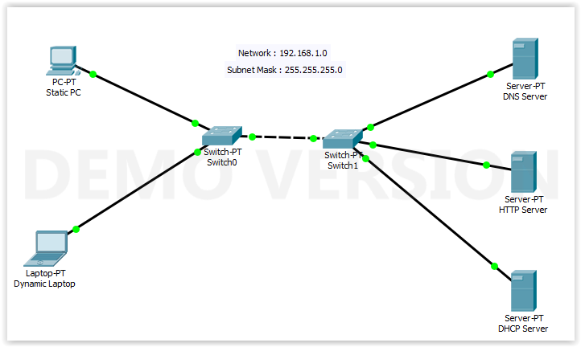

**Packet Tracer** **– Creating a Simple Network Using Packet Tracer Topology**

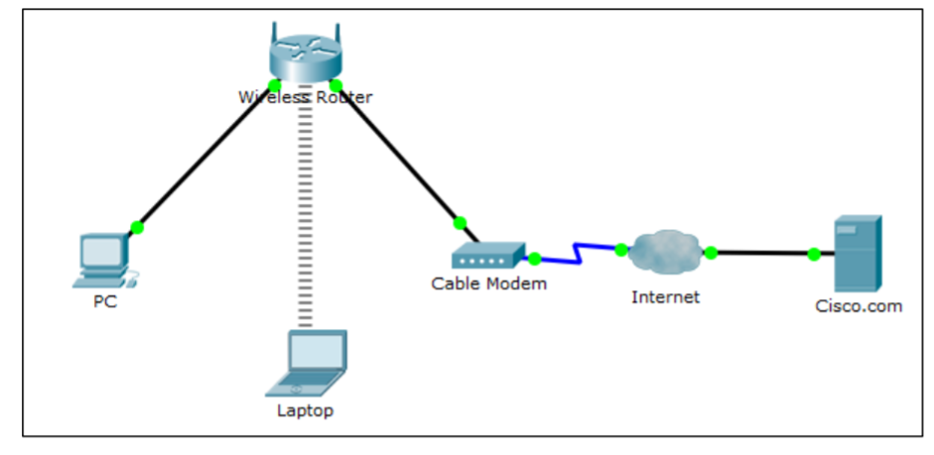

**Address Table**

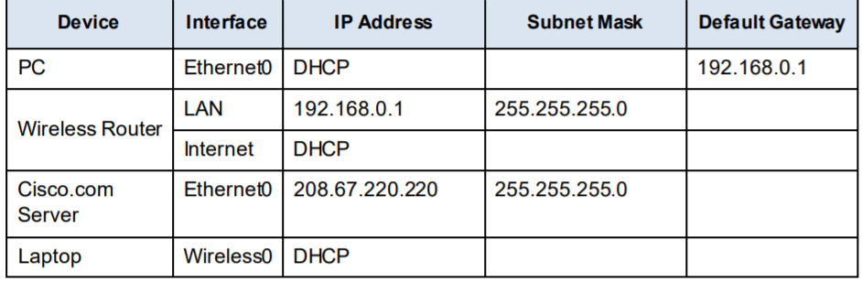

**Objectives**

Part 1: Build a Simple Network in the Logical Topology Workspace

Part 2: Configure the Network Devices

Part 3: Test connectivity between network devices

Part 4: Save the File and Close Packet Tracer

**Background / Scenario**

In this activity you will build a simple network in Packet Tracer from scratch and then save the network as a Packet Tracer Activity File (.pkt).

**Part 1: Build a Simple Network in the Logical Topology Workspace**

**Step 1: Launch Packet Tracer**.

1. Launch Packet Tracer on your PC or laptop computer

Double click on the Packet Tracer icon on your desktop or navigate to the directory that contains the Packet Tracer executable file and launch Packet Tracer. Packet Tracer should open with a blank default Logical topology workspace as shown in the figure.

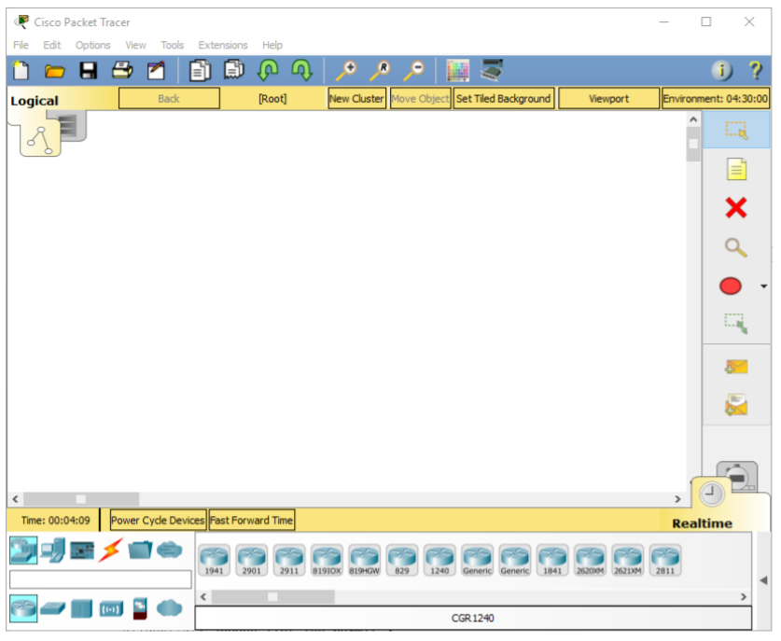

**Step 2: Build the topology**

1. **Add network devices to the workspace.**

Using the device selection box, add the network devices to the workspace as shown in the topology diagram.

To place a device onto the workspace, first choose a device type from the Device-Type Selection box. Then, click on the desired device model from the Device-Specific Selection box. Finally, click on a location in the workspace to put your device in that location. If you want to cancel your selection, click the Cancel icon for that device. Alternatively, you can click and drag a device from the Device-Specific Selection box onto the workspace.

1. **Add network devices to the workspace.**

Using the device selection box, add the network devices to the workspace as shown in the topology diagram.

To place a device onto the workspace, first choose a device type from the Device-Type Selection box. Then, click on the desired device model from the Device-Specific Selection box. Finally, click on a location in the workspace to put your device in that location. If you want to cancel your selection, click the Cancel icon for that device. Alternatively, you can click and drag a device from the Device-Specific Selection box onto the workspace.

1. **Change display names of the nework devices.**

To change the display names of the network devices click on the device icon on the Packet Tracer Logical workspace, then click on the Config tab in the device configuration window. In the Config tab type the new name of the device into the Display Name box as show in the figure.

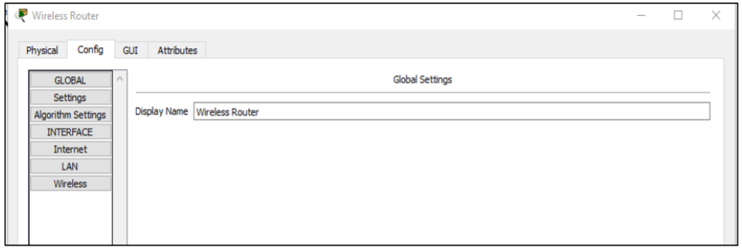

1. **Add the physical cabling between devices on the workspace.**

Using the device selection box, add the physical cabling between devices on the workspace as shown in the topology diagram.

The PC will need a copper straight-through cable to connect to the Wireless Router. Select the copper straight-through cable in the Device-Selection box and attach it to the FastEthernet0 interface of the PC and the Ethernet 1 interface of the Wireless Router.

The Wireless Router will need a copper straight-through cable to connect to the Cable Modem. Select the copper straight-through cable in the Device-Selection box and attach it to the Internet interface of the Wireless Router and the Port 1 interface of the Cable Modem.

The Cable Modem will need a coaxial cable to connect to the Internet cloud. Select the coaxial cable in the Device-Selection box and attach it to the Port 0 interface of the Cable Modem and the coaxial interface of the Internet cloud.

The Interne cloud will need copper straight-through cable to connect to the Cisco.com server. Select the copper straight-through cable in the Device-Selection box and attach it to the Ethernet interface of the Internet cloud and the FastEthernet0 interface of the Cisco.com server.

**Part 2: Configure the Network Devices**

**Step 1: Configure the Wireless Router**

1. **Create the wireless network on the Wireless Router**

Click on the Wireless Router icon on the Packet Tracer Logical workspace to open the device configuration window.

In the Wireless Router configuration window click on the GUI tab to view configuration options for the Wireless Router.

Next, click on the Wireless tab in the GUI to view the wireless settings. The only setting that needs to be changed from the defaults is the Network Name (SSID). Here, type the name “HomeNetwork” as shown in the figure

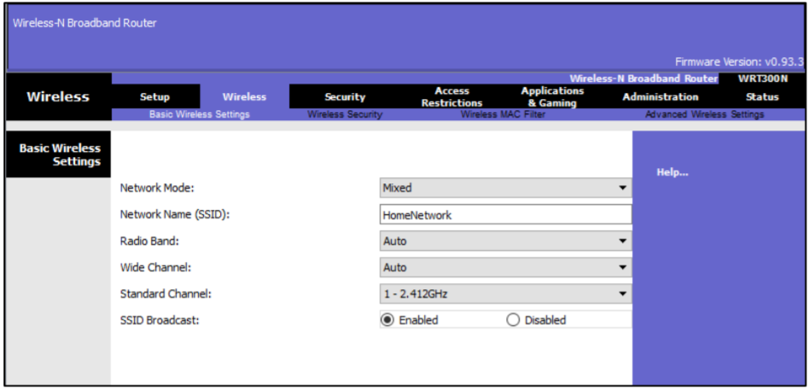

1. **Configure the Internet connection on the Wireless Router**

Click on the Setup tab in the Wireless Router GUI.

In the DHCP Server settings verify that the Enabled button is selected and configure the static IP address of the DNS server as 208.67.220.220 as shown in the figure.

1. **click on the Save Settings tab**

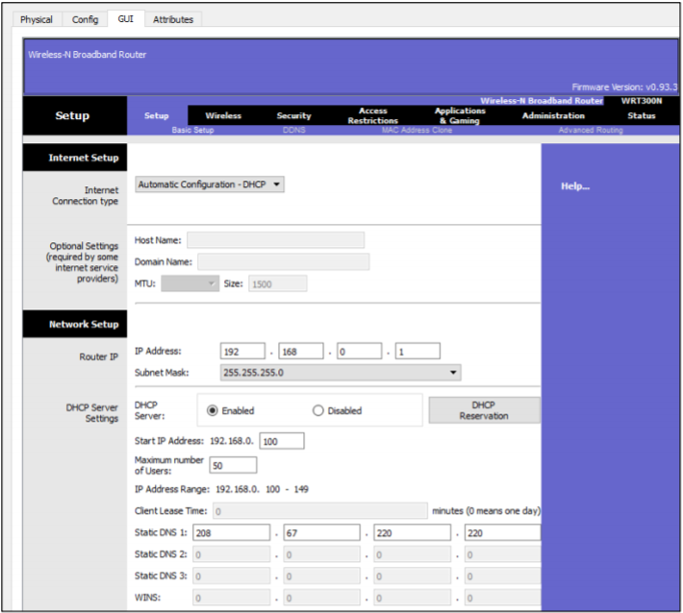

**step 2: Configure the Laptop**

1. **Configure the Laptop to access the wireless network**

Click on the Laptop icon on the Packet Tracer Logical workspace and in the Laptop configuration windows select the Physical tab.

In the Physical tab you will need to remove the Ethernet copper module and replace it with the Wireless WPC300N module.

To do this, you first power the Laptop off by clicking the power button on the side of the laptop. Then remove the currently installed Ethernet copper module by clicking on the module on the side of the laptop and dragging it to the MODULES pane on the left of the Laptop window. Then install the Wireless WPC300N module by clicking on it in the MODULES pane and dragging it to the empty module port on the side of the laptop. Power the laptop back on by clicking on the Laptop power button again.

With the wireless module installed, the next task is to connect the laptop to the wireless network.

Click on the Desktop tab at the top of the Laptop configuration window and select the PC Wireless icon. Once the Wireless-N Notebook Adapter settings are visible, select the Connect tab. The wireless network “HomeNetwork” should be visible in the list of wireless networks as shown in the figure. Select the network, and click on the Connect tab found below the Site Information.

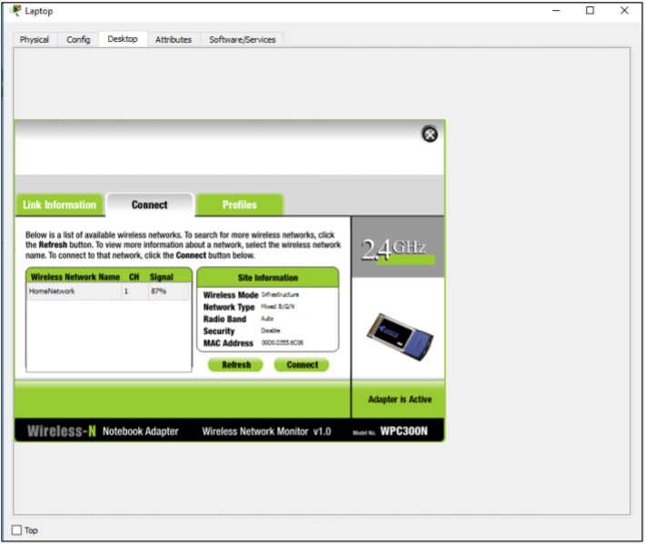

**Step 3: Configure the PC**

1. **Configure the PC for the wired network**

Click on the PC icon on the Packet Tracer Logical workspace and select the Desktop tab and then the IP Configuration icon.

In the IP Configuration window, select the DCHP radio button as shown in the figure so that the PC will use DCHP to receive an IPv4 address from the Wireless router. Close the IP Configuration window.

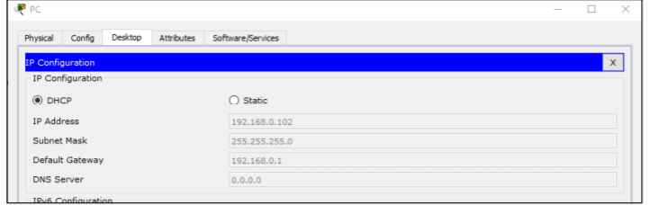

Click on the Command Prompt icon. Verify the PC has received an IPv4 address by issuing the ipconfig /all command from the Command as shown in the figure. The PC should receive an IPv4 address in the 192.168.0.x range

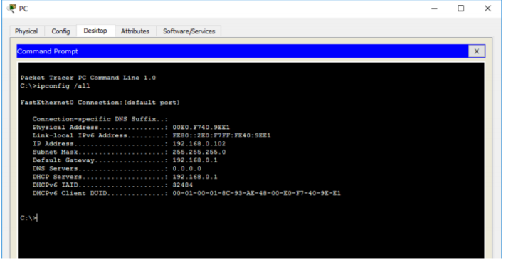

**Step 4: Configure the Internet cloud**

1. **Install network modules if necessary**

Click on the Internet Cloud icon on the Packet Tracer Logical workspace and then click on the Physical tab. The cloud device will need two modules if they are not already installed. The PT-CLOUD-NM-1CX which is for the cable modem service connection and the PT-CLOUD-NM-1CFE which is for a copper Ethernet cable connection. If these modules are missing, power off the physical cloud devices by clicking on the power button and drag each module to an empty module port on the device and then power the device back on.

1. **Identify the From and To Ports**

Click on the Config tab in the Cloud device window. In the left pane click on Cable under CONNECTIONS. In the first drop down box choose Coaxial and in the second drop down box choose Ethernet then click the Add button to add these as the From Port and To Port as shown in the figure.

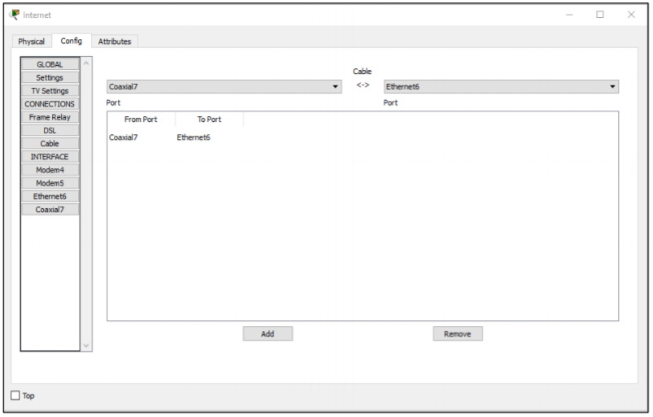

1. **Identify the type of provider**

While still in the Config tab click Ethernet under INTERFACE in the left pane. In the Ethernet configuration window select Cable as the Provider Network as shown in the figure.

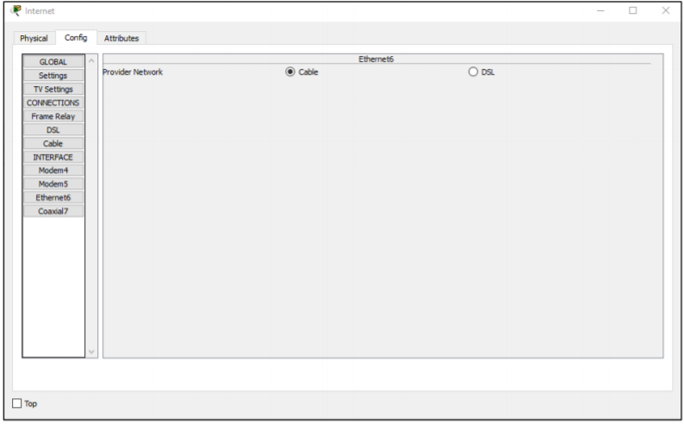

**Step 5: Configure the Cisco.com server**

1. **Configure the Cisco.com server as a DHCP server**

Click on the Cisco.com server icon on the Packet Tracer Logical workspace and select the Services tab. Select DHCP from the SERVICES list in the left pane.

In the DHCP configuration window, configure a DHCP as shown in the figure with the following settings

Click On to turn the DCHP service on

• Pool name: DHCPpool

• Default Gateway: 208.67.220.220

• DNS Server: 208.67.220.220

• Starting IP Address: 208.67.220.1

• Subnet Mask 255.255.255.0

• Maximum number of Users: 50

Click Add to add the pool

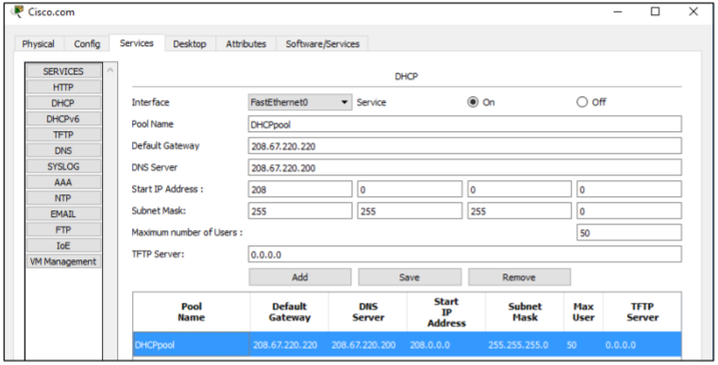

1. Configure the Cisco.com server as a DNS server to provide domain name to IPv4 address resolution. Still in the Services tab, select DNS from the SERVICES listed in the left pane.

Configure the DNS service using the following settings as shown in the figure.

• Click On to turn the DNS service on

• Name: Cisco.com

• Type: A Record

• Address: 208.67.220.

Click Add to add the DNS service setting

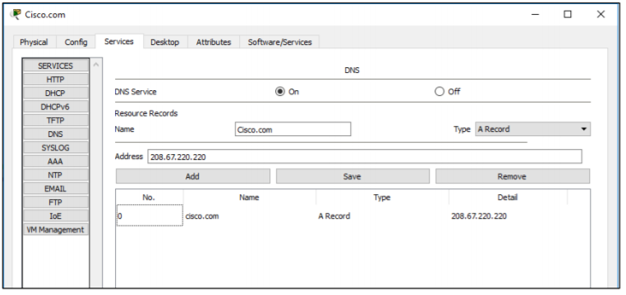

1. **Configure the Cisco.com server Global settings**.

Select the Config tab.

Click on Settings in left pane.

Configure the Global settings of the server as follows:

• Select Static

• Gateway: 208.67.220.1

• DNS Server: 208.67.220.220

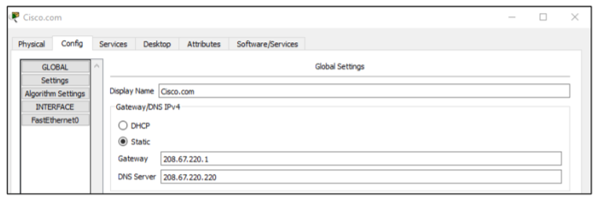

1. Configure the Cisco.com server FastEthernet0 Interface settings.

Click on FastEthernet in left pane of the Config tab

Configure the FastEthernet Interface settings of the server as follows:

• Select Static under IP Configuration

• IP Address: 208.67.220.220

• Subnet Mask: 255.255.255.0

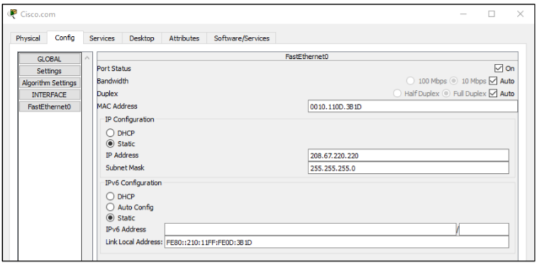

**Part 3: Verify Connectivity**

**Step 1: Refresh the IPv4 settings on the PC**

1. Verify that the PC is receiving IPv4 configuration information from DHCP.

Click on the PC on the Packet Tracer Logical workspace and then the select the Desktop tab of the PC configuration window.

Click on the Command Prompt icon .

In the command prompt refresh the IP settings by issuing the commands ipconfig /release and then ipconfig /renew. The output should show that the PC has an IP address in the 192.168.0.x range, a subnet mask, a Default Gateway, and DNS server address as shown in the figure.

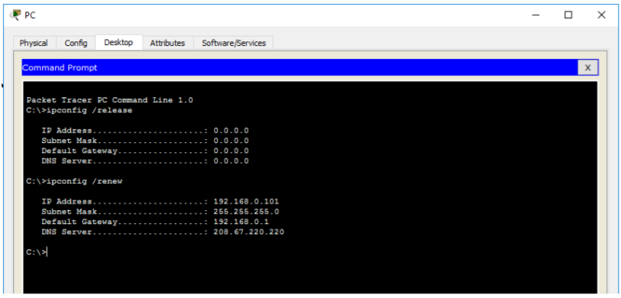

1. Test connectivity to the Cisco.com server from the PC

From the command prompt issuing the command ping Cisco.com. It may take a few seconds for the ping to return. Four replies should be received as shown in the figure

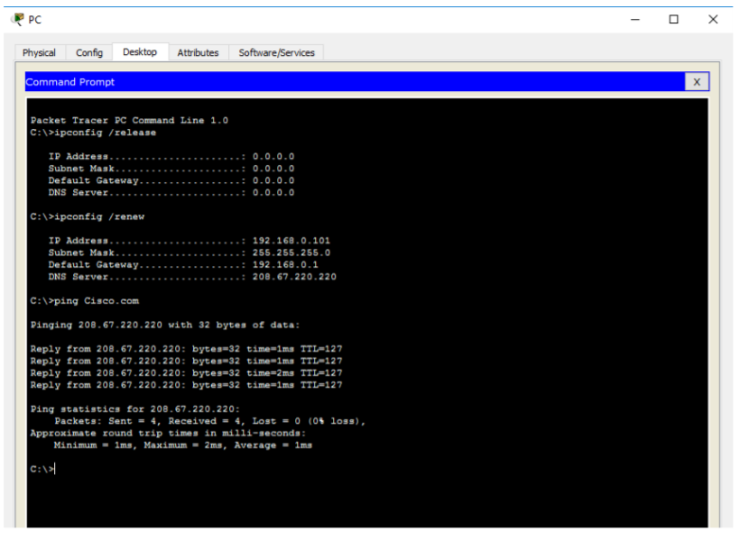

**Part 4: Save the File and Close Packet Tracer**

**Step 1: Save the File as a Packet Tracer Activity File (*.pkt)**

To save the completed network click on File in the Packet Tracer Menu bar and then select Save As… from the dropdown menu. In the the Save File window choose a directory to save the file to and give the file an appropriate file name. The Save as type defaults to Packet Tracer Activity File (*.pkt). Click Save to save the file.

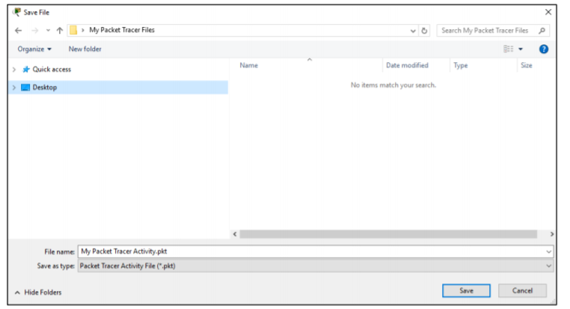

**Step 2: Close Packet Tracer**

To close Packet Tracer you can either click the “X” in the top right corner of the Packet Tracer window, or click on Exit in the File drop down menu.